Mobile County Training School Alumni Association
Bell and Brick Dedication
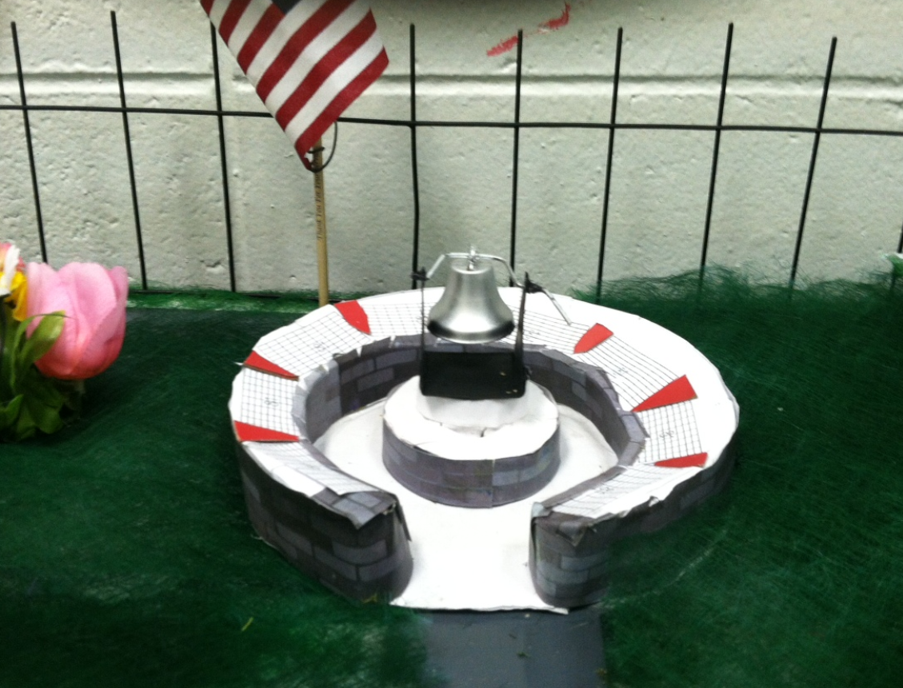
August 23rd, 2017
11:00 am
MCTS Campus
800 Whitley Street - Plateau, Alabama 36610

“Each one…Reach One…Teach One…And Never Give Up On Anyone”

